Development documentation

17.5.23

I added the navigation bar on the top of the header tag by following from this website <https://www.w3schools.com/css/tryit.asp?filename=trycss_navbar_basic_css>.

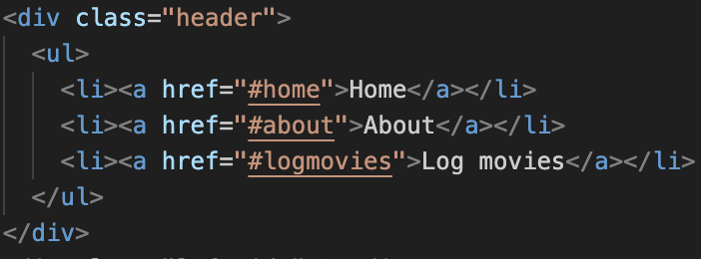

19.5.23

Because navigation bar still has dot point. I got help from Rob to reset my css using this link which contains the code.

<https://meyerweb.com/eric/tools/css/reset/>

Additionally, I linked one stylesheet to reset.css to remove dot points from my navigation bar then added style.css and scss/main.scss stylesheets because linking css to main.scss through @import does not work.

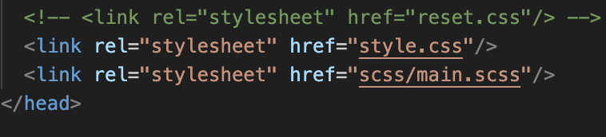

I changed the layout from grid to flex because it’s responsive to both mobile and desktop devices.

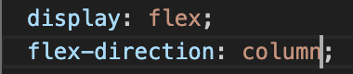

Hence, I added my images using the img tag with figcaptions as part of figure tag in html. And added align-self to figcaption in css to position below the image.

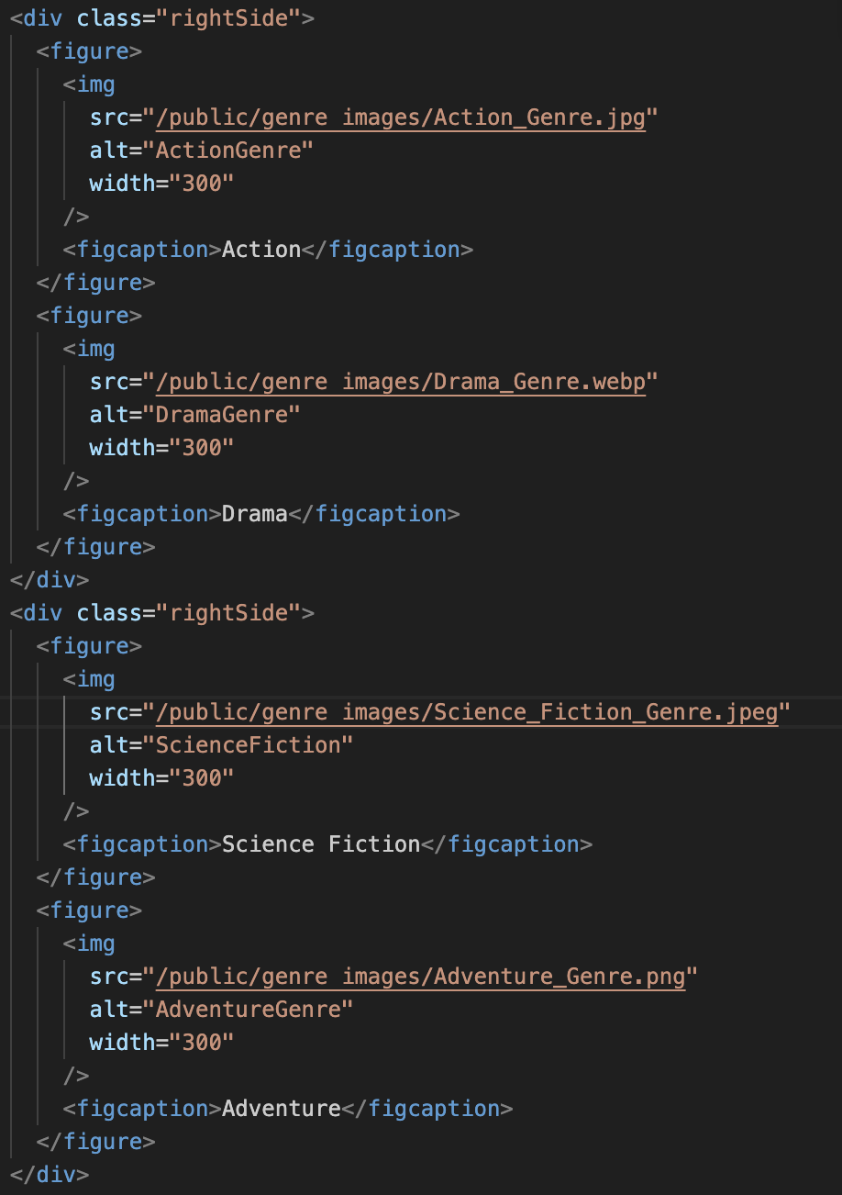

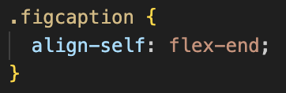

20.5.23

I created a form consists of User First Name, User Last Name, User Id, Movie Genre, Phone Number, Email, Movie Name, Rating and Movie image. Using template from coding challenge.

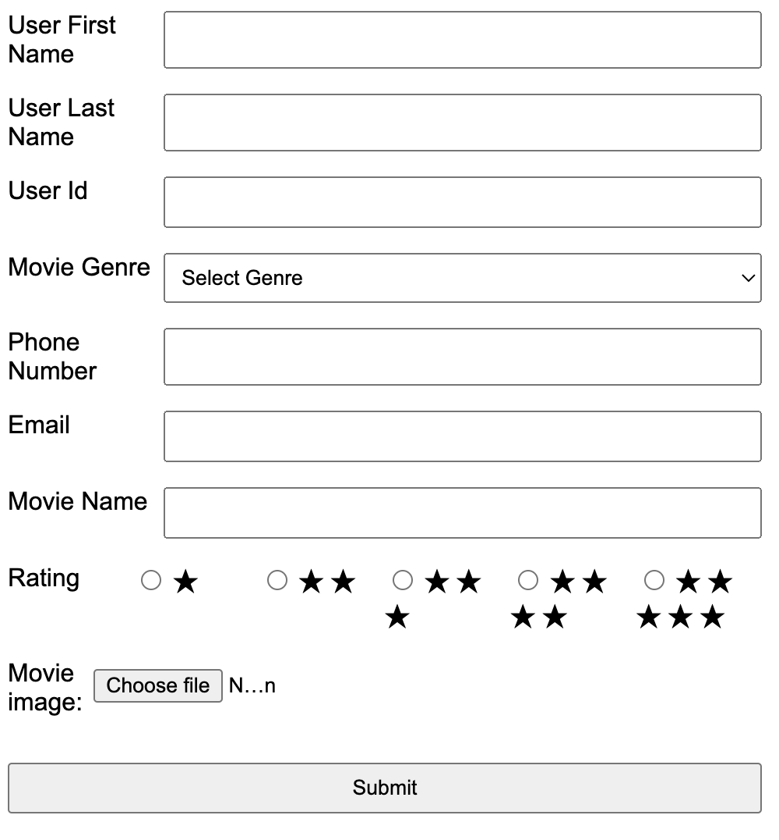

I found information about how to create a rating system for users to input data to the form. By classifying input type as radio and adding stars using span class.

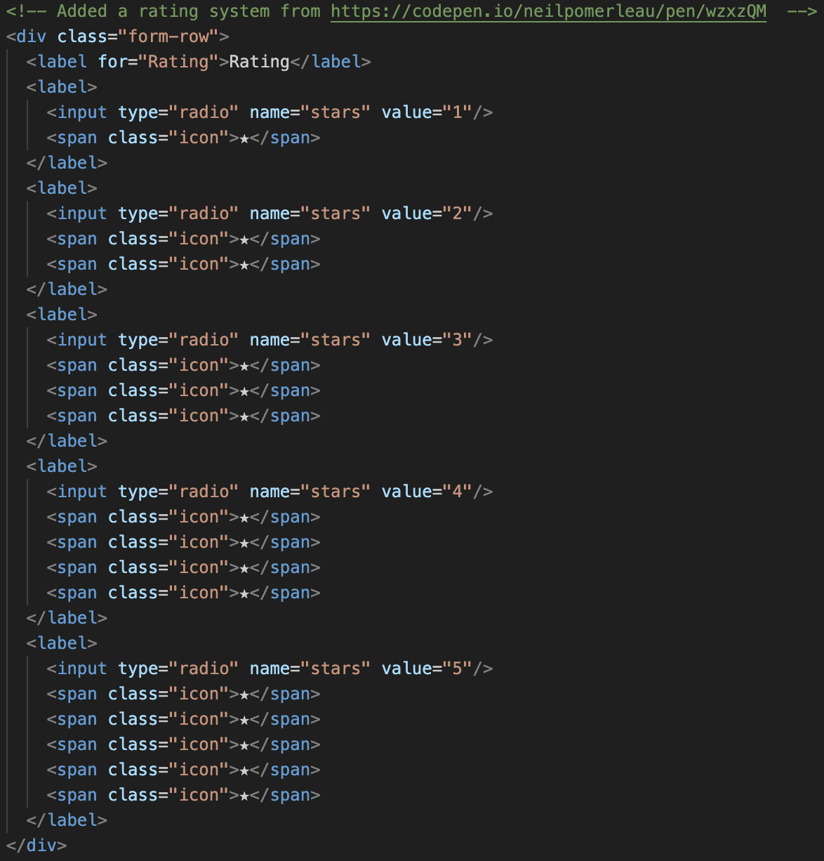

And to add image when user searches for their image from a folder.

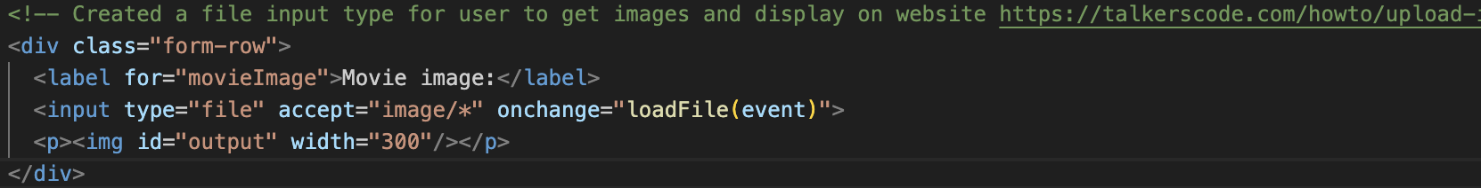

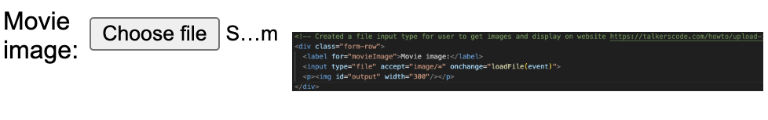

21.5.23

I placed my form on left and tasks at the right side of my website. By using margin-top: -16em - form tag and Tasks: margin-left: 60em for Tasks tag.

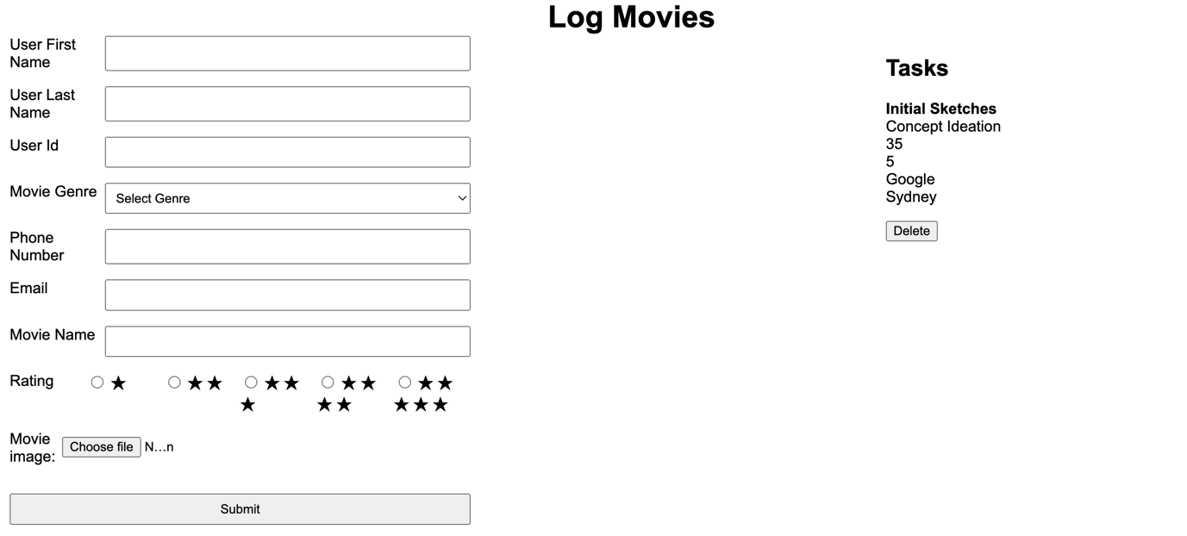

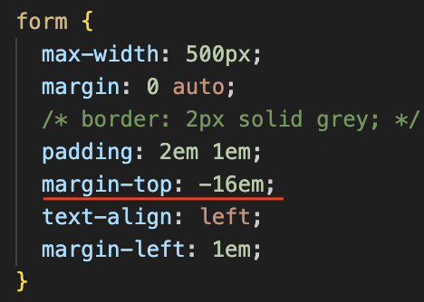

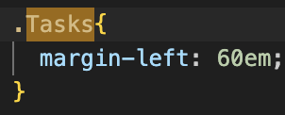

Furthermore, I created a task list that enables the user to select a task and display it individually. Watched a video on YouTube about showing/hiding div based on dropdown selection using HTML, CSS and jQuery. And converting to plan JavaScript using codentools.com.

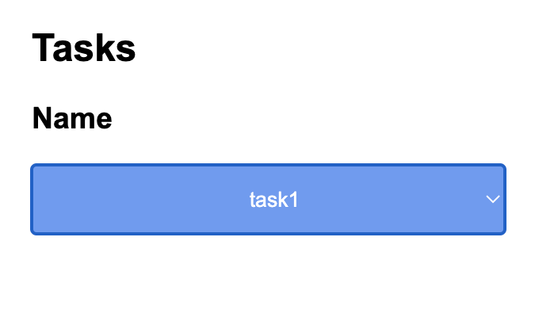

<https://www.youtube.com/watch?v=f3fALMAVBOE>

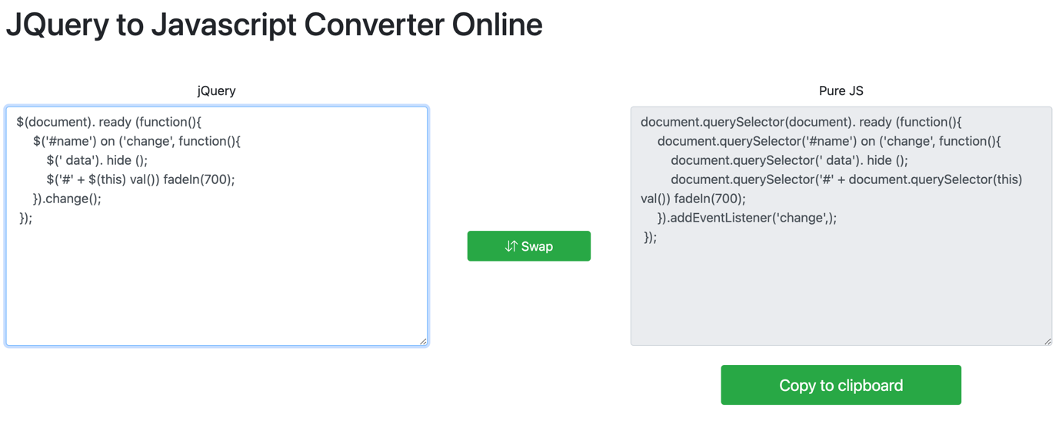

Additionally, I moved the labels of my form to the top and user input to the bottom and adjusted my submit button.

For navigation bar I used my web app design assignment to create a menu that’s positioned on the left side and title at the center.



And I resetted my css by placing on top of the styles.css file.

<https://www.digitalocean.com/community/tutorials/css-minimal-css-reset>

22.5.23

I aligned the title images, context and types of genres to centre of my website.

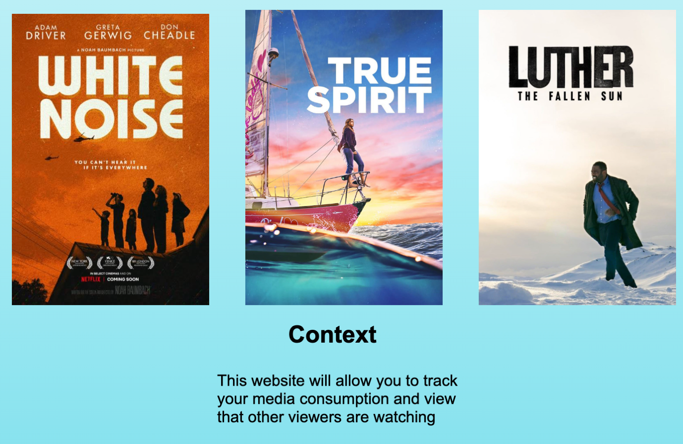

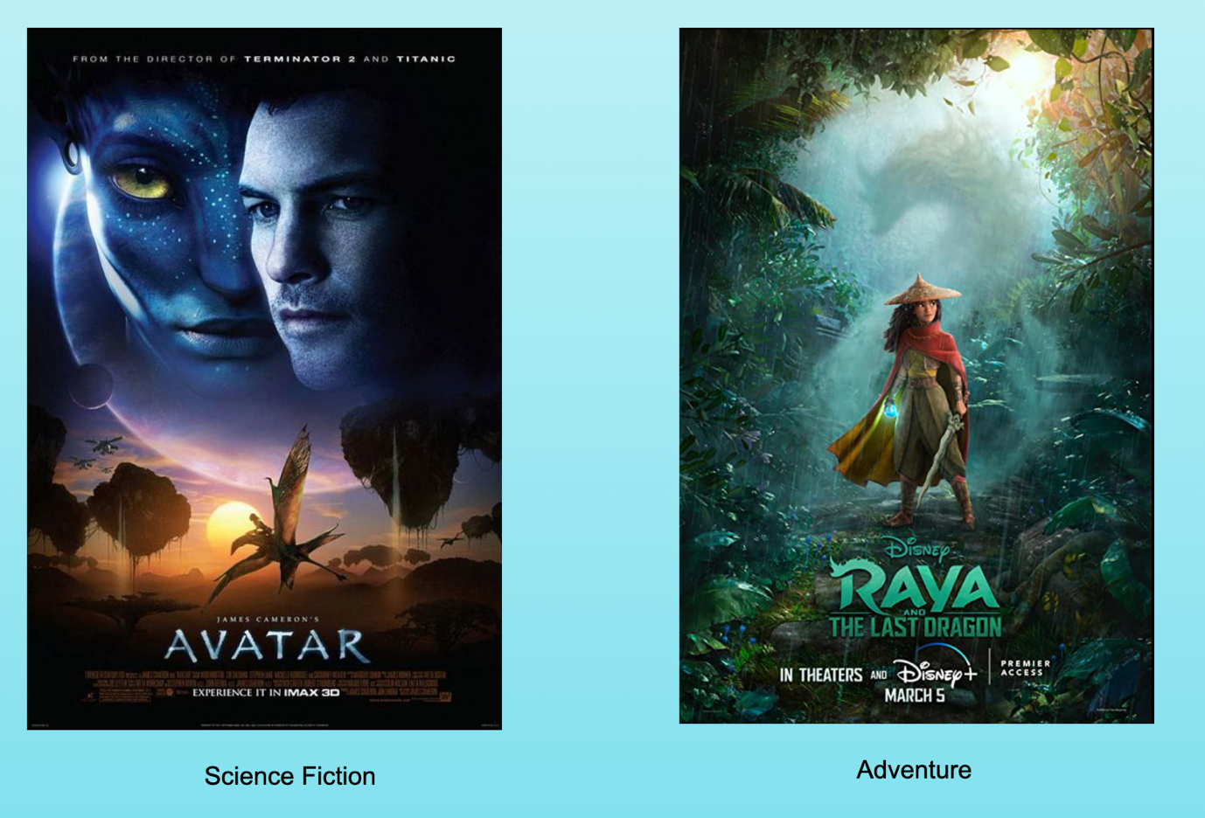

I changed form by adding a background image for each input and added JavaScript for user to select a date they submit the form from <https://stackoverflow.com/questions/71953018/html-input-date-field-how-to-set-default-value-to-todays-date>.

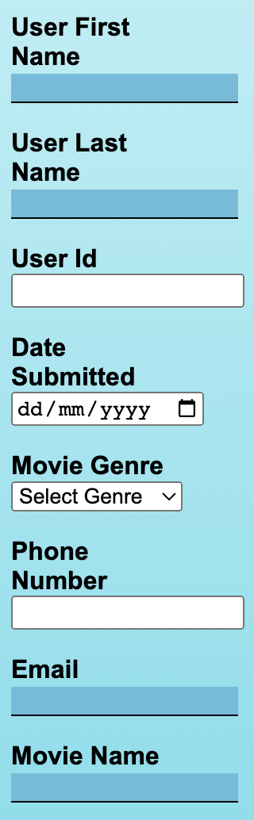

In addition, I added a rating in relation to movie name using pure CSS Star Rating Input from <https://codepen.io/neilpomerleau/pen/wzxzQM>.



I finalised by form and added footer to the bottom of my html document. I found it strange that the image does not pop up when I select an image.

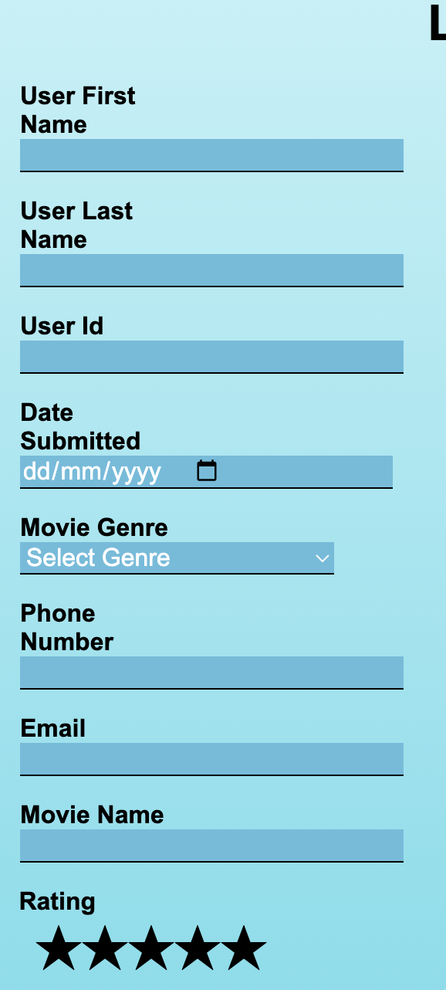

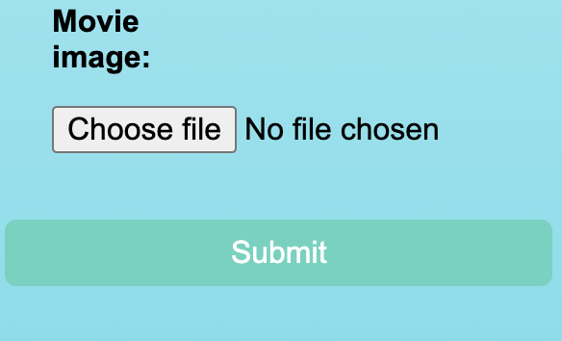

Added a trash bin emoji next to the task list using this link: <https://stackoverflow.com/questions/3705804/css-positioning-elements-next-to-each-other>.

Furthermore, I created animations for my title images using fadeIn for 5 seconds. It does not work on my computer and tried to view animation from the developer tools, but it’s takes too long.

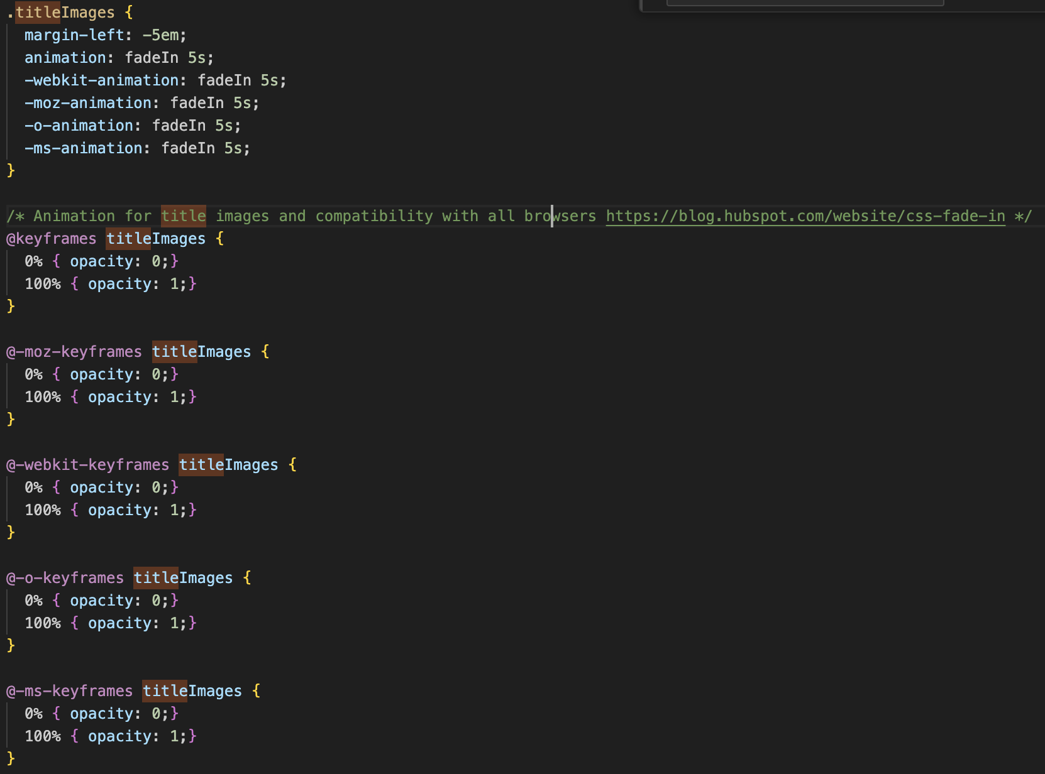

I attempted to edit some JavaScript code to display user’s input but it’s not working. The console displays 2 errors which is frustrating.



24.5.23

I edited all html elements to fit within the resolution of mobile by adjusting margins and reducing size of top header fonts.

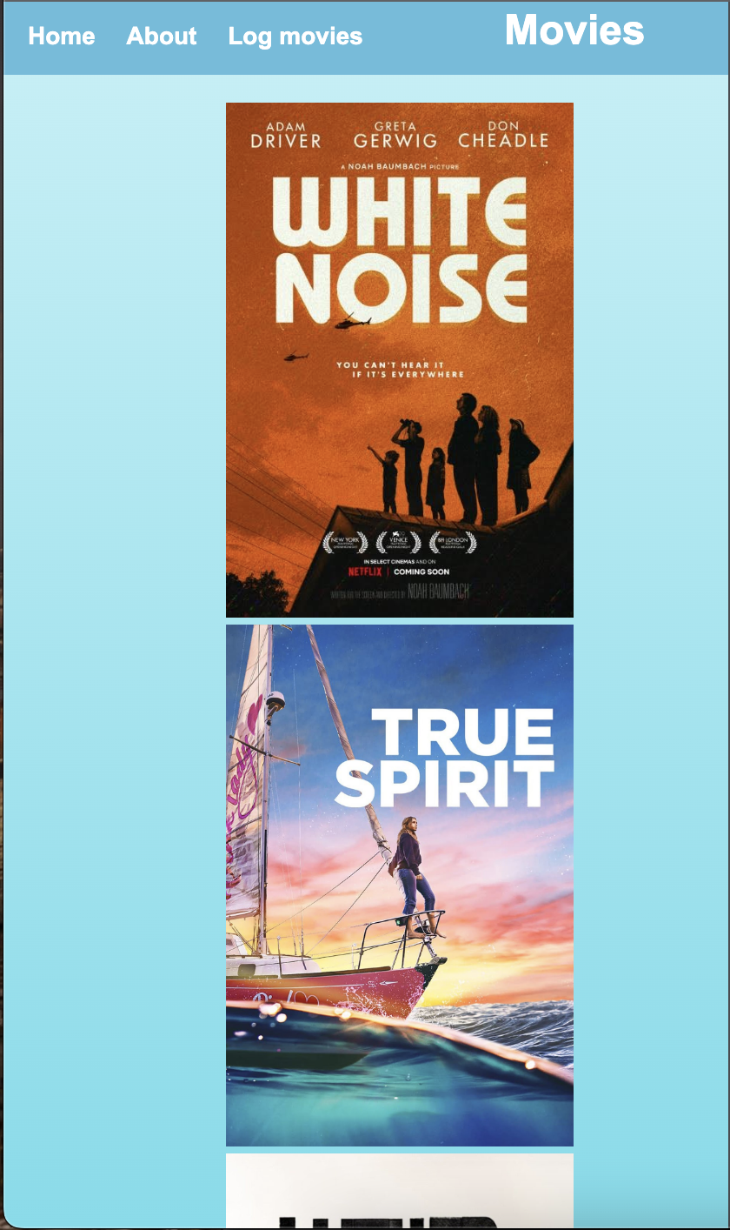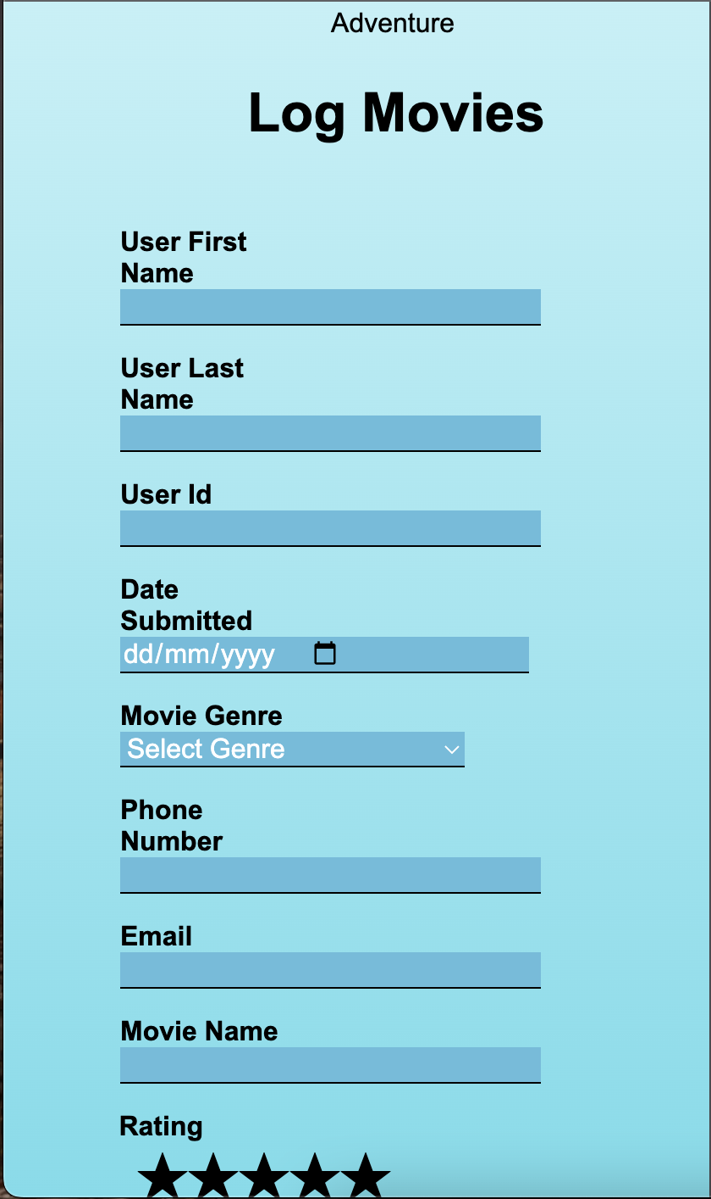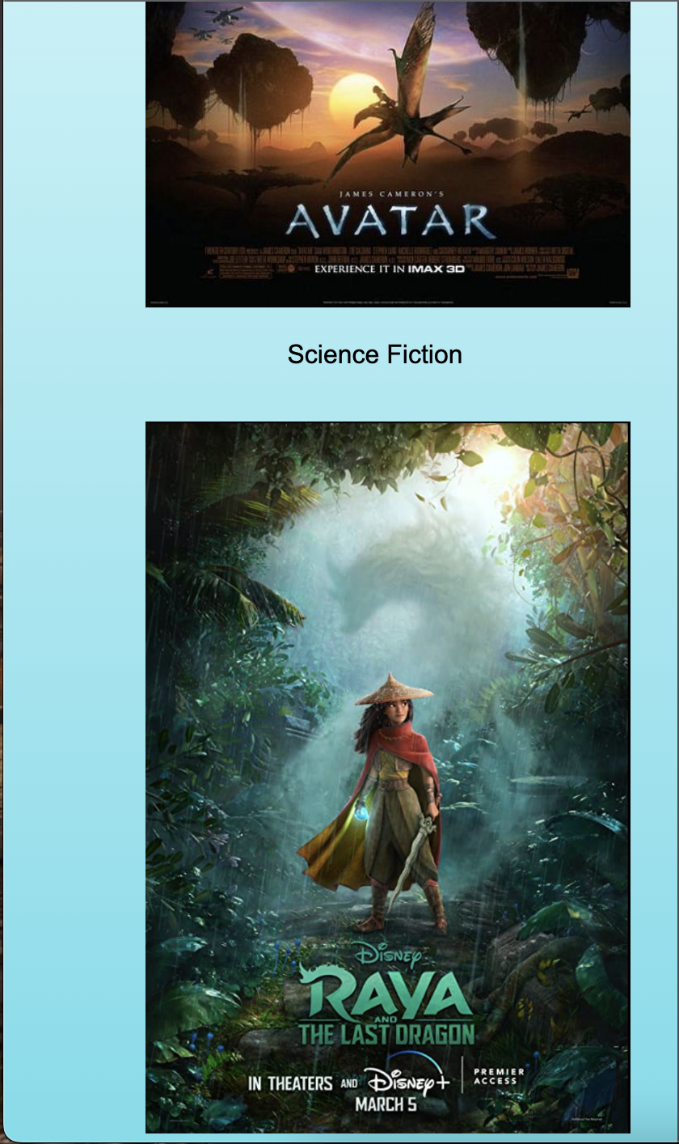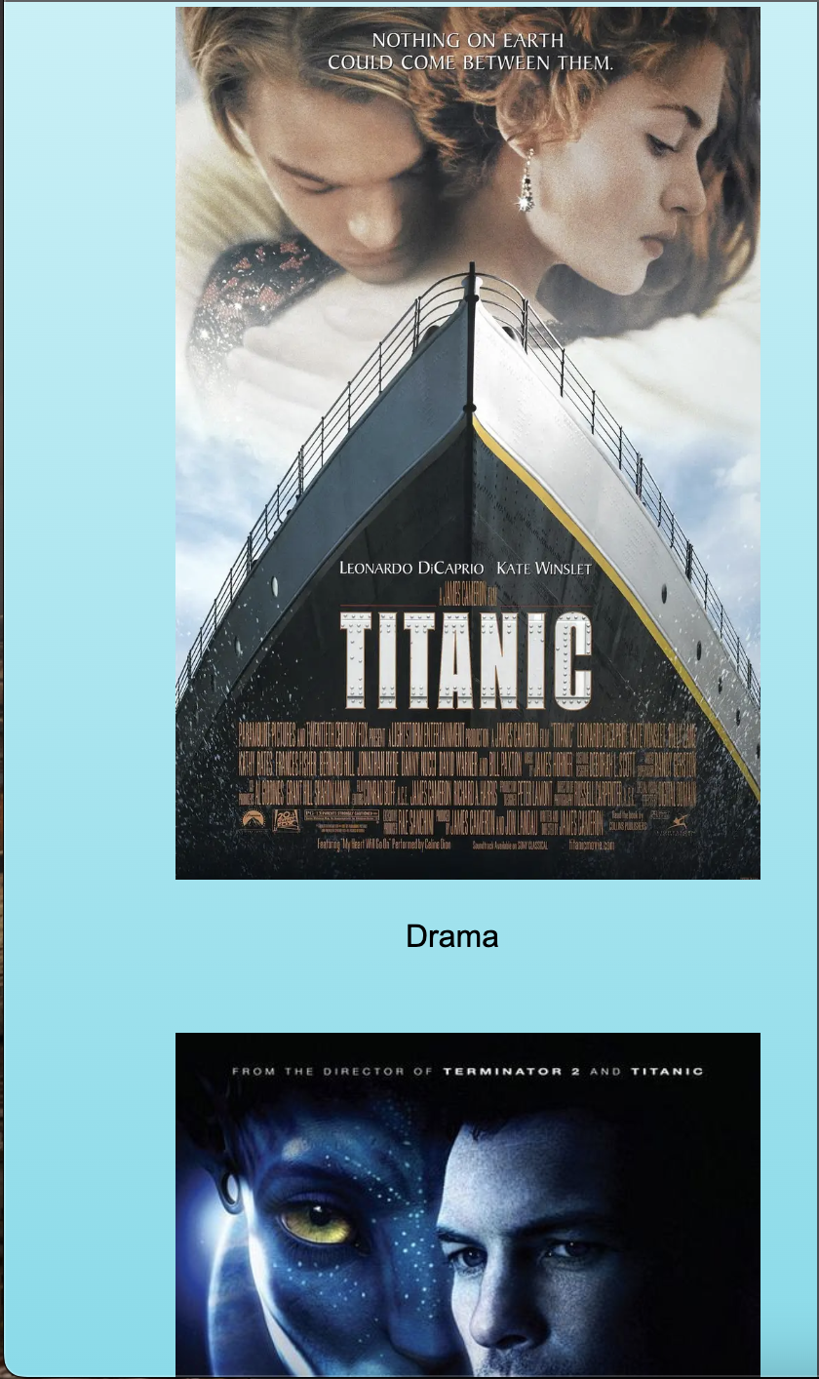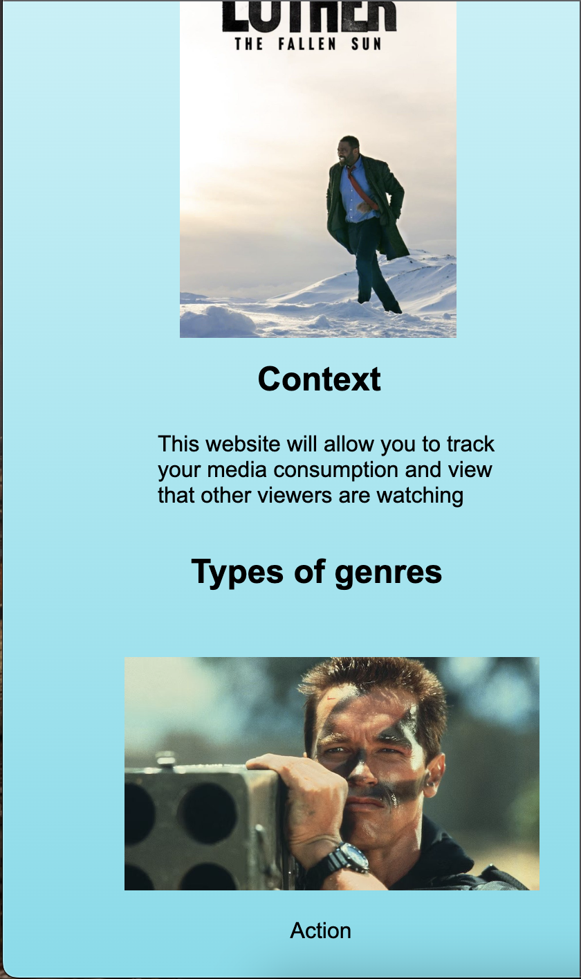

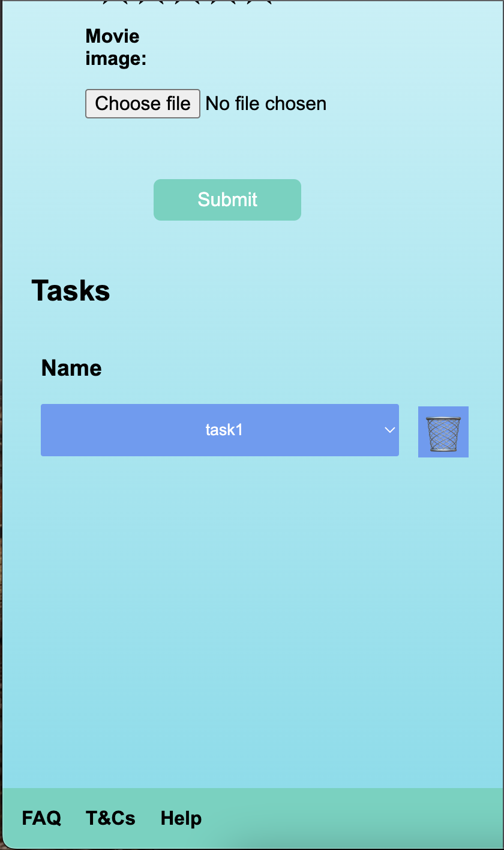

Furthermore, added min and max for both user Id and phone number to prompts users to enter the correct value.

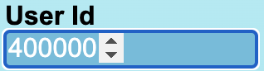

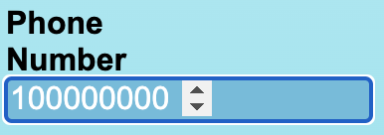

Added comments to all HTML, CSS, and JavaScript for users to understand my code.

Hence, I attempted to fix the problem by changing .ready - jQuery to .onDOMContent - Javascript but it’s displaying an error to the console.



26.5.23

I added a function to hide the trash button when the website is starting and reveals as user clicks to select their tasks. A problem is when they click on their tasks, the trash button does not appear.

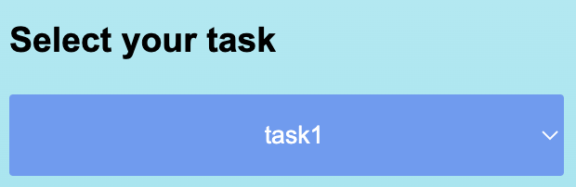

27.5.23

I create an a href tag for the user to submit to content div tag, displaying user input from form.

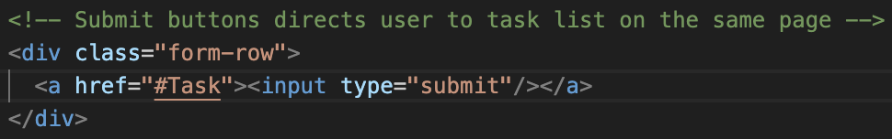

Additionally, I changed my code because there’s still errors when linking to .DOMContentLoaded from the previous link.

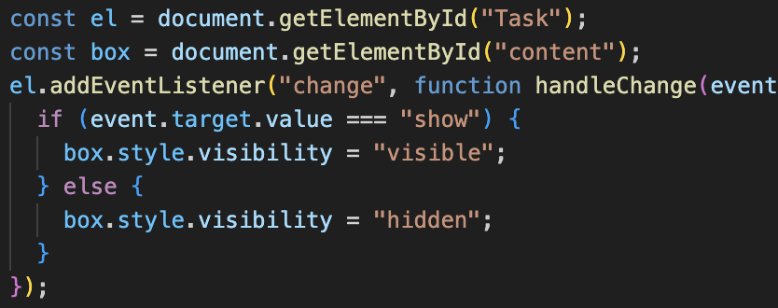

Removed a query selector for the rating system because it does not work.

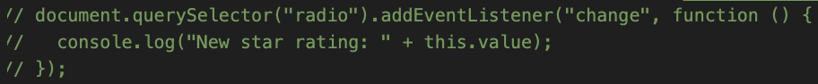

Deleted .value from form.addEventListener as the console displays an error when I click submit.

Hence, I adjusted all elements of my website to spread evenly within the page and reduced the width from 768 to 750px.

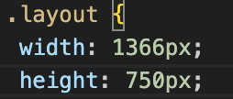

29.5.23

I checked my Script.js file to make sure all input types have a name and defined within my code.

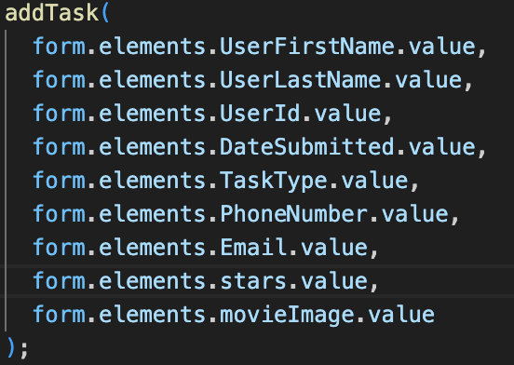

Furthermore, I made all the input name and id to camelCase to reduce errors when user submits their form.

I changed my input names and id to start with “user” so that I don’t have to define for function displayTask.

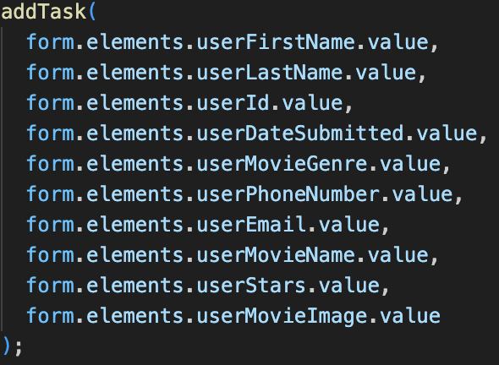

In conclusion, creating a website for both desktop and mobile is challenging. There are recommendations made to this assignment if developed further.

* Generate images of movies from users.
* Have the header on the top stretched to optimize with different desktop sizes.
* Create a popup about each movie genre for users to understand.
* Use padding to user id and mobile so that the last number isn’t blocked from the form.
* Display the bin once the user finds their task.